**INTRODUCTION**

**1.1.Overview**

A business card is a small, printed, usually credit-card-sized paper card that holds your business details, such as name, contact details and brand logo. Your business card design is an essential part of your branding and should act as a visual extension of your brand design.

**1.2 Purpose**

Business cards are one way you can successfully market a company and expand its customer base. Professionals or business owners can use their personalized cards as a marketing tool to share pertinent contact information with potential customers and fellow small business owners.

**Problem Definition & Design Thinking**

2.1 Empathy Map

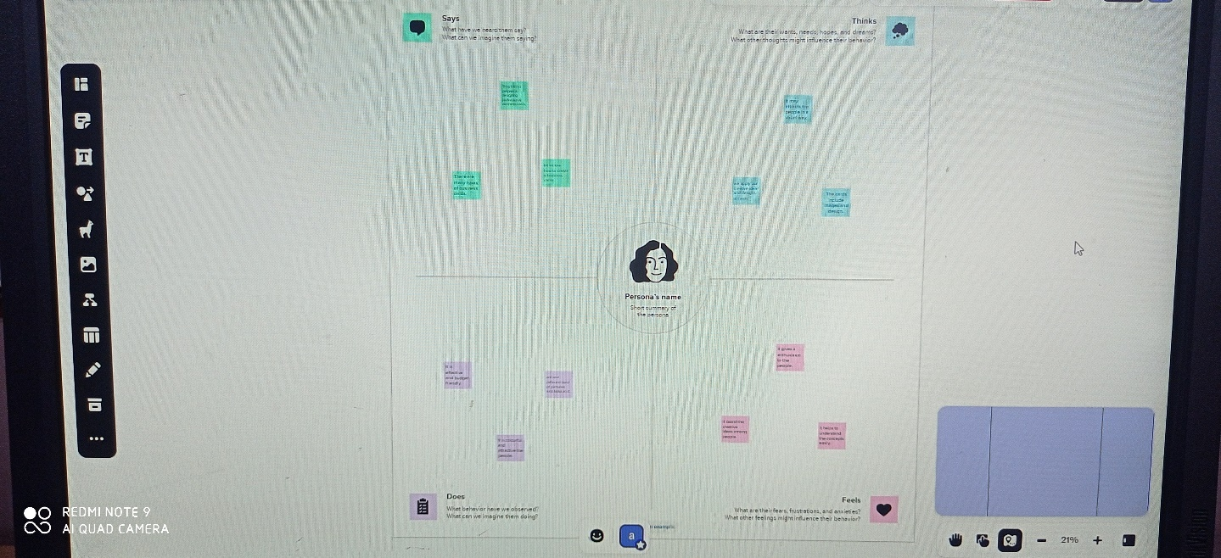

2.2 Ideation & Brainstorming map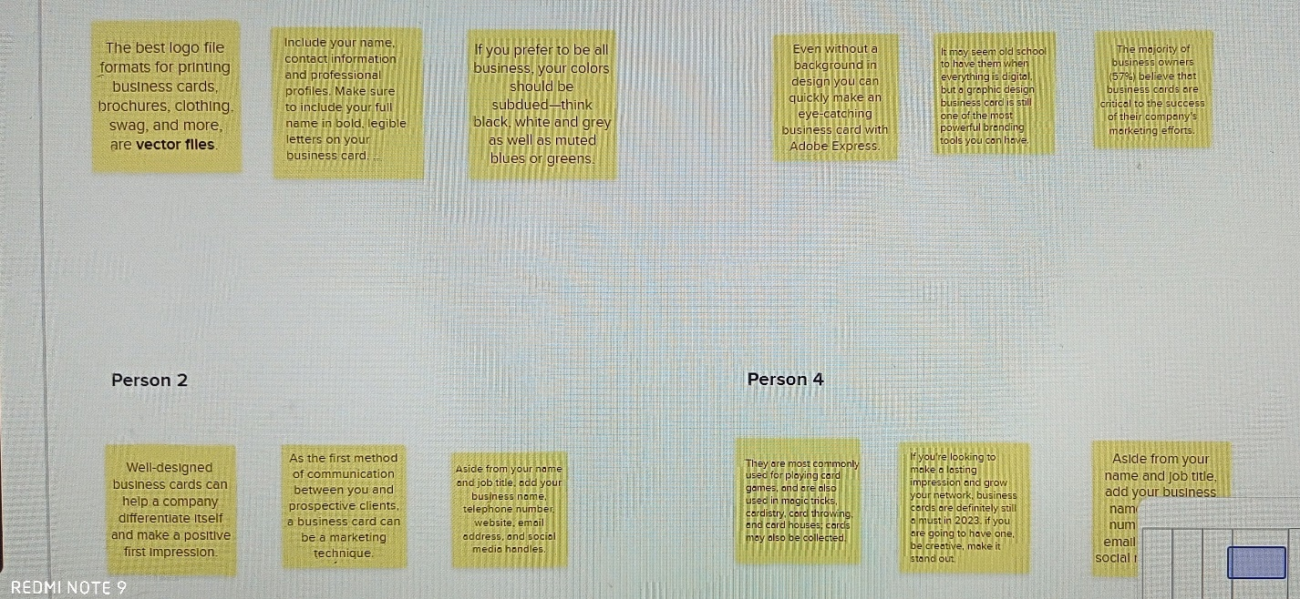

3.Result

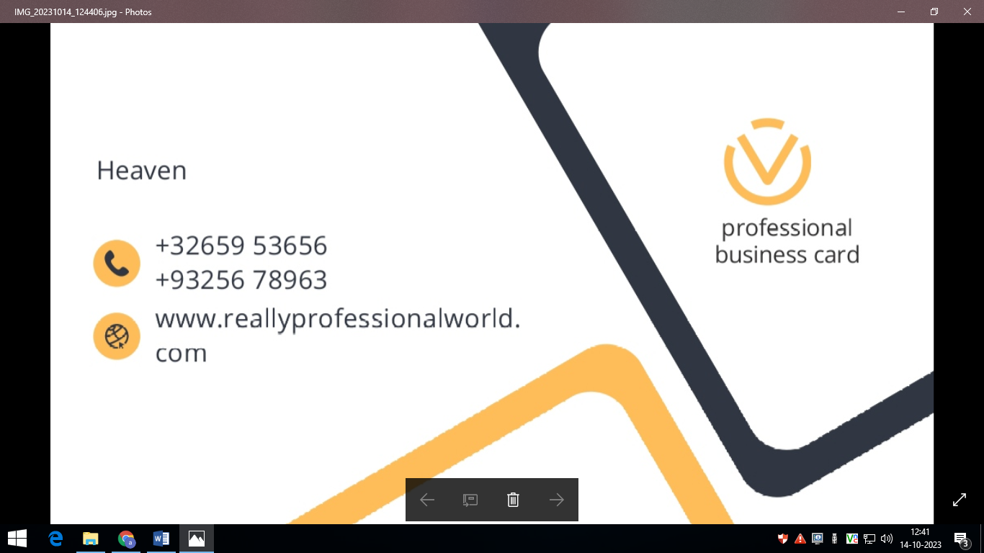

**4. Advantages & Disadvantage**

**Advantages**

* Affordable Advertisement.
* Perfect For Events.
* Tangible.
* Easy Distribution.
* People Won't Forget Your Email.
* Gives A Great First Impression.
* Small and Convenient.
* Gives A Visual Aid To Remember Your Business.

**Disadvantages**

* The cost to design and print. Creating a design that stands out and gets you noticed often requires help from a professional Graphic Designer.
* They need to be kept up-to-date.
* They have limited information.

**5. Application**

I have use mural app and canva app.

**6. Conclusion**

We have created Designing professional business cards post with the help of canva.

**7. Future scope**

We were planning to join the graphic designing course.